**Details of your portfolio**

PD URL site *(*Compulsory to fill up for milestone 2 and 3):*

*https://xjxcxb.github.io/index.html*

Name of your portfolio:

*Jacob Tan*

Your Logo:

Describe your target audience:

*I'm aiming to connect with potential employers. I recognize that my audience comprises professionals across diverse industries. Age, nationality, race doesn’t matter much to me, but I would like to be able to communicate with them well. Geographic location should be in Singapore. Their income levels should be steady or on the rise. Their educational backgrounds has to be trustworthy enough. Psychographically, they’re able to value skills, dedication, and the potential for growth in potential candidates like me.*

Describe your brand story/ purpose:

*I'm driven by the inspiration to apply my skills and expand my knowledge in a professional setting. I'm keen on showcasing my capabilities and learning within industries that value growth and potential.*

**Design brief**

Colour scheme & Colour palette:

*I used blue and white as my color scheme.*

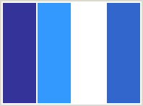

I choose blue and white for my portfolio's color scheme for a few important reasons. Blue represents trust and professionalism, qualities I want to convey. It also brings a sense of calm. White, on the other hand, represents cleanliness and simplicity, providing a clean backdrop for my content to stand out. This combination ensures readability and accessibility, allowing my work to shine while creating a professional and trustworthy impression. This creates a clean and professional look for my portfolio.

Typography:

I picked "Plus Jakarta Sans" for my portfolio site because it's modern, clean, and adaptable to my design needs. Its look matches what I like and helps me highlight and organize my content. Readability is key for showcasing my work, making it easy for visitors to explore. The font's professional style adds a polished touch that could appeal to employers or clients. Overall, it fits my style and elevates the vibe I want for my portfolio.

Theme:

Minimalistic for simplicity*, professionalism, calmness, and cleanliness*

Layout/ Arrangement:

*How will you arrange the multimodal composition in a way that makes sense for your audience and your purpose? How might you arrange ideas and elements so that your composition is effective?*

***Minimally 3 tabs with 2 layers of navigation***

Home

About

Contact

Portfolio

Submitted

**Low fidelity wireframe:**

**High fidelity wireframe** *(*Compulsory to fill up for milestone 2 and 3)***:**

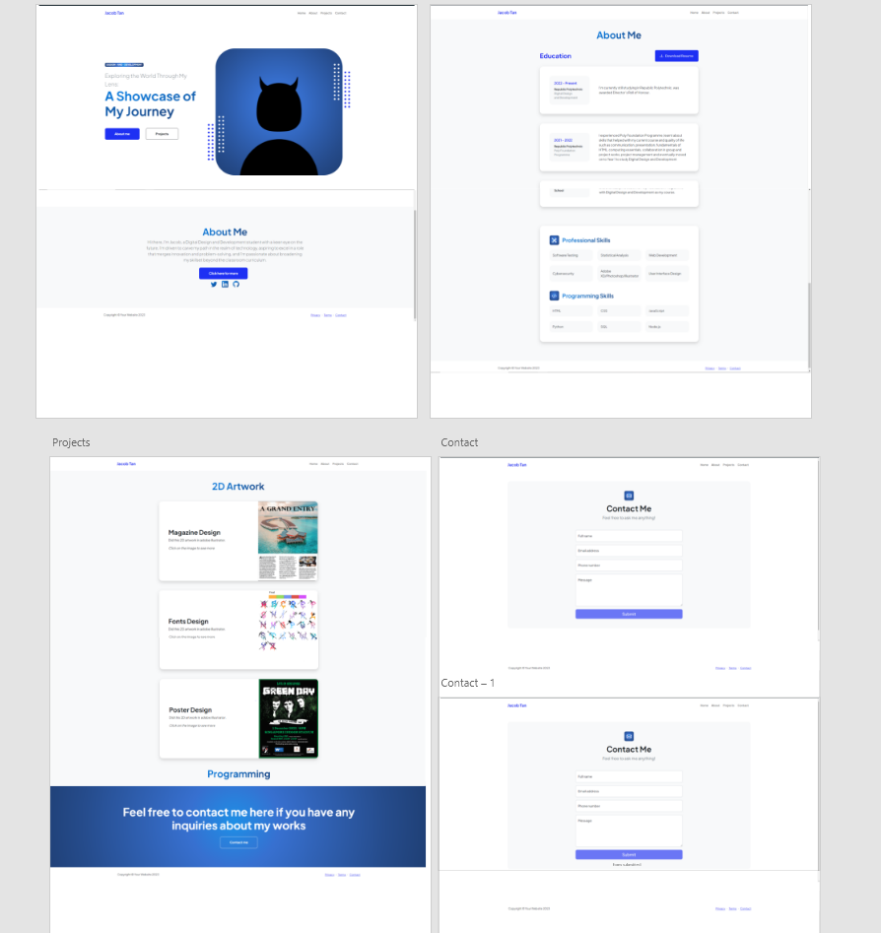

**Link in XD for your Prototype (make sure your lecturer is given access to the site)** *(*Compulsory to fill up for milestone 2 and 3)***:**

*https://xd.adobe.com/view/3720f306-0656-48e0-94a5-c3b29ccb44c8-6273/*

**Reference sites** *(*Optional)***:**

*Any reference websites you have make references*